**PROJECT DOCUMENTATION**

1. **INTRODUCTION**

## Insight Stream: Navigate the News Landscape

## **Project Title : Insight Stream: Navigate the News Landscape**



Team ID: NM2025TMID36516

Team Leader:

* Madhumitha. B [-24csmadhumitha051@gmail.com](mailto:-24csmadhumitha051@gmail.com)

Team Members:

* Manju. M [–24csmanju055@gmail.com](mailto:–24csmanju055@gmail.com)
* Mageshwari. V [–24csmageshwari053@gmail.com](mailto:–24csmageshwari053@gmail.com)
* Malathy. V [–24csmalathy054@gmail.com](mailto:–24csmalathy054@gmail.com)

**2**.**PROJECT OVERVIEW**

1. **PURPOSE:**

**The term "insight stream" can refer to different concepts, but generally, its purpose is to provide a continuously updated, personalized, and relevant flow of information or data to enable better understanding, decision-making, and action. For instance, in business and marketing, it creates a live feed of key performance indicators (KPIs) and market insights to help teams focus their attention and act quickly on recommendations. In technology, it refers to real-time event analytics that provide visibility across various data sources for anomaly detection and process automation. In a broader sense, the purpose is to distill complex data into actionable intelligence that drives business growth and organizational improvement.**

**Personalized News Feed:**

**Tools like Conductor's Insight Stream automatically generate a live feed of personalized search insights and important KPIs.**

**Focus and Action:**

**The goal is to help users focus on what's important without having to dig through data, and to allow for immediate action on recommendations.**

**Workflow and Communication:**

**It helps to expedite team workflows and streamline communication by providing a shared source of crucial insights for sharing and discussion.**

**Data-Driven Marketing:**

**Insight Stream Ltd uses its data-analysis process to help clients understand customers, deliver innovative marketing strategies, and maximize opportunities for communication.**

1. **FEATURES:**

* **Real-time Data Processing: The core function is to process continuous data in motion, enabling high-speed data ingestion and real-time analytics.**
* **Continuous Data Flow: Data streams are designed to handle large volumes of constantly changing data without interruption.**

* **Custom Dashboards & Reporting: Users can create on-demand reports and dynamic dashboards to visualize insights into various aspects of their data, such as customer usage or campaign performance.**
* **Machine Learning and Prediction: Configurable machine learning models can be used to identify patterns, make predictions about risk scores, cash flow, and customer behavior, and optimize processes.**
* **Fraud Detection and Security: Real-time analysis helps detect suspicious activities and security threats as they occur, enabling immediate response.**
* **Conversion and Campaign Optimization: Businesses can monitor conversions and marketing campaign success in real-time, allowing for timely adjustments to improve results.**
* **Personalization: By analyzing real-time user behavior, companies can deliver personalized content and offers to enhance engagement and increase conversions.**
* **Data Streaming and Integration: The platform can reliably stream data to other analytics applications or data lakes, supporting integration with tools like Microsoft Power BI.**

**3.ARCHITECTURE:**

* **Data Sources:**

**The origin of the real-time data, which can be sensors, log files, financial transactions, or social media feeds.**

**Captures and imports data into the system. Technologies like Apache Kafka or AWS Kinesis are used for efficient data collection and distribution.**

* **Streaming Transport:**

**Acts as a stream channel, moving data from the ingestion layer to processing components.**

**To navigate the news landscape effectively, consider the following architectural strategies:**

* **Multichannel Communication Approach:**

**Integrate multiple channels, including press releases, social media, blogs and influencer collaborations to amplify messages effectively.**

**Precision Pitching: Tailor press releases to align with journalists' current coverage, beats and audience interests.**

**Targeted Distribution and Personalization: Focus on building direct relationships with industry-specific journalists and influencers, and tailor pitches to increase media coverage opportunities.**

**AI-Driven Distribution and SEO: Leverage AI-powered distribution with SEO best practices to maximize visibility and engagement.**

**Building Genuine Relationships with Media: Develop meaningful relationships with media to ensure press releases have an impact.**

**Design Principles :**

**User-Centered Design: Prioritize accessibility and reader satisfaction in news landscape architecture.**

**Clear Structure: Ensure easy access to news categories and articles.**

**Visual Cues and Consistency: Use consistent placement of elements for easy navigation.**

**Mobile Optimization: Reach readers on-the-go with mobile-friendly designs.**

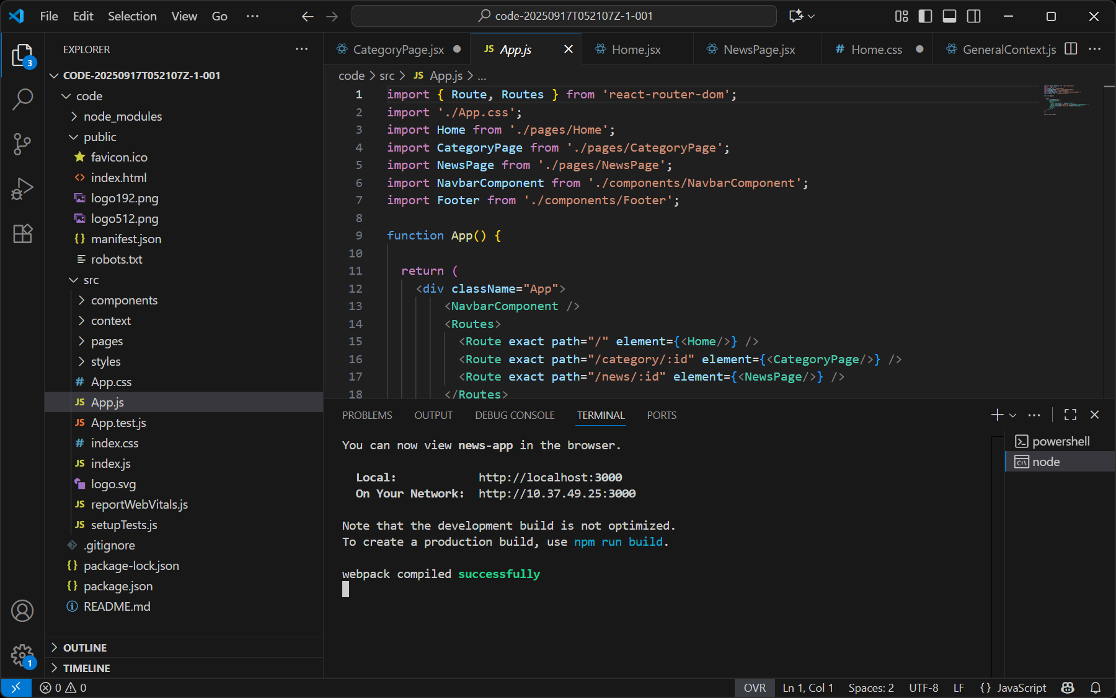

**Fig1.1 InsightStream :**

**Navigate the News Landscape architecture view.**

**4.SETUP INSTRUCTION:**

Backend-Specific Prerequisites

**Node.js & Express.js:**

**Understand how a backend server works. You should know how to create routes, handle HTTP requests, and manage middleware with Express.js, which is built on Node.js.**

**MongoDB & Mongoose:**

**While you'll learn the specifics of these two technologies, a basic understanding of database concepts is helpful. Mongoose is an Object Data Modeling (ODM) library that helps you interact with MongoDB from your Node.js application, so knowing how a schema works and what CRUD (Create, Read, Update, Delete) operations are is beneficial.**

**Here are the prerequisites for learning and working with MongoDB**

**1. Basic Computer Knowledge:**

**Comfort with installing software, navigating file systems, and using the command line or terminal.**

**Understanding how to configure environment variables if needed.**

**2. Programming Knowledge:**

**Basic knowledge of at least one programming language (Java, Python, Node.js, C#, etc.).**

**Familiarity with JSON (JavaScript Object Notation) since MongoDB stores data in BSON (Binary JSON).**

**3. Database Fundamentals:**

**Understanding of what a database is and why it is used.**

**Basic concepts: tables/collections, records/documents, primary keys/identifiers.**

**Awareness of the difference between SQL (relational databases) and NoSQL (MongoDB).**

**Fig1.2 Node JS.**

**Definition:**

**Node.js is an open-source, cross-platform, JavaScript runtime environment that allows you to run JavaScript code outside of a web browser.**

Frontend-Specific Prerequisites

**React.js:**

**To work with React, you should be familiar with its core concepts, such as components, state, props, and hooks. Knowing how to manage the user interface and handle user events is fundamental.**

**Integrated Development Environment (IDE)**

**Visual Studio Code (VS Code):**

**While not a prerequisite for the technologies themselves, VS Code is the recommended and most widely used code editor for this stack. Familiarity with its interface, extensions, and built-in features will significantly boost your**

**5.FLODER STRUCTURE:**

**📂 Navigate-the-News-Landscape**

**│**

**├── 📂 Images/**

**│ ├── news-landscape-diagram.png**

**│ ├── fake-vs-real-news.jpg**

**│ ├── media-bias-chart.png**

**│**

**├── 📂 Research-Papers/**

**│ ├── scholarly-article-1.pdf**

**│ ├── scholarly-article-2.pdf**

**│**

**├── 📂 Drafts/**

**│ ├── draft-version1.docx**

**│ ├── draft-version2.docx**

**│**

**├── 📂 Final-Output/**

**│ ├── Navigate-the-News-Landscape-Final.docx**

**│ ├── Navigate-the-News-Landscape-Final.pdf**

**│**

**└── 📂 Presentations/**

**├── Navigate-the-News-Landscape.pptx**

**├── Key-Findings-Slides.pptx**

**6.RUNNING THE APPLICATION:**

**FRONTEND:**

**cd client:**

**cd stands for change directory. This command is used to navigate between folders in your file system.**

**client is the name of the folder where the frontend code is located. Many full-stack projects separate the frontend from the backend into folders named client and server (or frontend and backend).**

**This command changes your current location in the terminal from the project's root directory to the client folder.**

**npm start:**

**npm stands for Node Package Manager. It's a command-line tool that comes with Node.js and is used to manage project dependencies and run scripts.**

**start is a pre-defined script in the package.json file of a project. When you run npm start, it executes a command (often react-scripts start or a similar command) that launches the development server for your frontend application.**

**This server runs locally on your machine, allowing you to view and test your application in a web browser. It also enables features like hot reloading, where changes to your code are automatically reflected in the browser without a manual refresh.**

**BACKEND:**

**cd server:**

**cd stands for change directory. This command is used to move between folders in your file system.**

**server is the name of the folder where the backend code is located. In many full-stack projects, the backend and frontend are separated into distinct directories, often named server and client respectively.**

**This command changes your current location in the terminal from the project's root directory to the server folder.**

**7. User Interface:**

**User Interface – Navigate the News Landscape**

**The application provides a clean and interactive interface to help users explore, evaluate, and understand news effectively. The design focuses on simplicity, usability, and credibility.**

**Home Page / Dashboard**

**Top Navigation Bar:**

**Logo & App Name (“News Navigator”)**

**Search Bar (search by keyword/topic)**

**Categories (Politics, Sports, Technology, Health, Business, World News, etc.)**

**User Profile / Login**

**Main Content Area:**

**Latest News Section (real-time updates)**

**Trending Stories (from multiple sources)**

**Recommended for You (based on interests/history)**

**Fact-Checked News Highlights**

**Sidebar:**

**Filter by Source (e.g., BBC, The Hindu, Times of India, NDTV, etc.)**

**Filter by Date / Region**

**Quick Links (Bookmarks, Saved Articles, Verified Sources)**

**8.TESTING:**

**Testing – Navigate the News Landscape**

**Testing ensures that the system works as expected, delivers accurate news content, and provides a smooth user experience.**

**1. Functional Testing**

**News Feed Test: Verify that the latest and trending news are displayed correctly**

**Search Function Test: Ensure users can search news by keywords, category, or source.**

**Filter Test: Check filters (date, region, publisher) return accurate results.**

**Article View Test: Validate that clicking on a headline opens the full article.**

**Save/Bookmark Test: Confirm saved articles appear in the user’s profile.**

**Fact-Check Tab Test: Ensure misinformation and verified tags are displayed correctly.**

**2. Usability Testing**

* **Test navigation flow (Home → Article → Save → Back).**
* **Check clarity of interface (icons, categories, labels).**
* **Validate responsiveness on multiple devices (mobile, tablet, desktop).**
* **Ensure accessibility features (font size, dark/light mode, alt text for images).**

**3. Performance Testing**

**Load Testing:**

**Verify the app can handle multiple users fetching news simultaneously.**

**Speed Test:**

**Ensure news articles load within 2–3 seconds.**

**Database Performance: Validate fast retrieval of bookmarks and reading history.**

**4. Security Testing**

**Test user login/logout functionality.**

**Verify password encryption and secure session handling.**

**Check data protection for saved bookmarks and personal preferences.**

**Ensure no unauthorized access to admin panel.**

**5. Compatibility Testing**

**Verify the app works on Chrome, Firefox, Edge, and Safari.**

**Test on Android and iOS devices.**

**Validate API integration with multiple news sources.**

**6. User Acceptance Testing (UAT):**

**Conduct testing with sample users**

**Collect feedback on news accuracy, interface design, and ease of navigation.**

**Make improvements based on real user experience.**

**Expected Outcome:**

**The system should deliver accurate, verified news.**

**Users should be able to navigate seamlessly between sections.**

**Bookmarks, filters, and comparisons should function without errors.**

**Application should remain secure, fast, and reliable.**

**9.AUTHENTICATION:**

**To navigate the modern news landscape, focus on the authentication of content by ensuring accuracy and transparency, which builds trust and credibility for both news sources and the content itself. This involves implementing rigorous fact-checking, verifying information through transparent processes, using authentic storytelling, and investing in diverse, credible spokespeople. For news consumers, authentication means understanding how news is presented and using credibility indicators to distinguish reliable sources from misinformation.**

**For News Organizations & Content Creators**

**Prioritize Fact-Checking and Verification:**

**Implement robust processes to verify information, especially in the face of rampant misinformation.**

**Be Transparent:**

**Maintain transparency in all communications, which fosters trust and credibility.**

**Develop Authentic Storytelling:**

**Share genuine, relatable stories that align with your brand's values and mission to build loyalty.**

**Train and Vet Spokespeople:**

**Cultivate a bench of credible, well-trained spokespeople who can articulate your organization's message with authenticity and clarity.**

**Invest in Digital Innovation:**

**Use technology to create interactive features and personalized experiences, which can enhance credibility and engagement for subscribers.**

**Understand Your Audience:**

**Conduct market research to understand what matters to your target audience and tailor your content to their needs.**

**For News Consumers**

**Assess Credibility Indicators:**

**Look beyond headlines and consider the overall perception of a source, its content, and the context of the information.**

**Rely on Trusted Sources:**

**Be less susceptible to false information by relying on trusted news sources that invest in fact-checking and verification processes.**

**Be Skeptical of Emotionally Charged Content:**

**Be aware of cognitive biases and avoid trusting content solely based on its visual appeal or emotional impact.**

**Verify Information:**

**Take the time to verify information from multiple reputable sources before accepting it as fact.**

